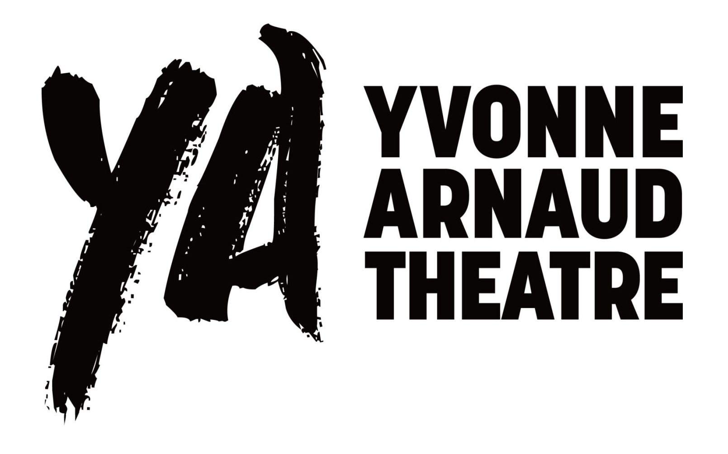

Main House Technical Specification

Please note: YAT cannot be held responsible for any costs incurred resulting in information, assumptions or omissions from this document. It is the responsibility of the visiting company to check critical dimensions before visiting the theatre. Please check the availability of equipment before planning show needs around it.

Contents
Contacts 4
Seating Capacity 4
Access 4
Stage Information and Dimensions 5
Flying Information 5
Stage Equipment 5
Orchestra Pit 6
Stage Management 7
Control Positions 7
Wardrobe 7
Dressing Rooms 8
Lighting 9
Touring Company Power 9
Control Equipment 9
Dimmers 9
Permanent FOH LX Rig 10
Profile Stock 10
Fresnel Stock 10
Beamlight Stock 10
Cyc/Floods Stock 10
Followspots 10
Rigging Information 11
Sound 12
Mixing Position/Tielines 12
Permanent Sound Rig 12
Sound Power 12
Amps/Sound Cards 12
Video/AV 13
Pre-Show Announcement System 13
Appendix A – Equipment Available for Hire 14
Appendix B – Seating Plan 15
Appendix C – Hanging Plot 16

IMPORTANT NOTICE FOR THE PRODUCTION AND COMPANY MANAGER

Along with so many theatres in recent years the Yvonne Arnaud currently runs with no Arts funding and a slashed council funding therefore we have had to up our endeavours to bring income in to the building in order to stay open.
As part of a drive to bring businesses to our building for corporate meetings and presentations we have to utilise our auditorium as much as possible.
Our main objective, however, is to ensure any visiting company has main priority over anything else.
Please could you give us as much notice as possible of your stage use after your opening night and, if there is a situation where a business has made a daytime booking ahead of yourselves, we would ask for your co-operation and compromise with regards to allowing us the opportunities to maximise our potential income.

Contacts
All technical queries regarding from visiting companies should be directed to the following:
Head of Production & Technical Manager
Liza Cheal lcheal@yvonne-arnaud.co.uk 01483 443941
(Please channel all show info through this 1 email pathway).
Deputy Technical Manager, Sound & AV: Chris Champness.
Senior Lighting Technician: Matt George.

Website: www.yvonne-arnaud.co.uk
Address: Yvonne Arnaud Theatre, Millbrook, Guildford, Surrey, GU1 3UX

Seating Capacity
Stalls 410
Circle 176
Total 586
The following number of seats will be lost for:
- Small Orchestra Pit (lose centre Row A) 10 seats
- Medium Orchestra Pit (lose Row A) 18 seats
- Large Orchestra Pit (lose Rows A & B) 39 seats
- Auditorium Right Followspot position (in circle) 1 seat
If you require seats to be held off sale, you must notify us as far in advance as possible. We may not be able to hold seats once they are on sale. This is normally agreed at the contractual stage. For Seating Plan please see Appendix B.

Access
The Yvonne Arnaud’s dock door is accessed via Millbrook (A281) just outside the town centre past the Debenhams department store. W3W orange.recall.yoga
Size of these double doors are width and height of a artic mega trailer. Any vehicles larger than a 7.5ton truck will be unable to turn around outside the theatre so must reverse in off the main road. The doors are approximately 600mm (2’) above street level giving flat access to the stage via ramp from trailer height.
Trailers are unable to stay on the doors after the fit-up and before the get-out due to access requirements. Trucks arriving early for the get-out must park on the main road till marshalled in.
On first arrival Access is via the Box Office reception through the main theatre doors front of house. Visitors will be issued with a key fob to access rear of house through the stage door which is unmanned. The box office reception staff will give out keys, packages and notices. Opening times are 1000hrs until half an hour after performance ends unless company rider states other requirements.

Stage Information and Dimensions
The stage floor is made up of original 30mm thick boards and finished with 6mm hardboard painted Mylands Silk Black. It can be screwed into and painted as necessary but must be reinstated back to normal as part of the get-out and at cost to the visit company.
Due to the layout of the structure underneath the stage traps are unable to be installed in the floor. If your show requires access from substage to stage as part of the action please call to discuss as far in advance as possible
False Proscenium width 10,100 mm 33’2”
False Proscenium height (variable on winch) 4,570 – 5,490 mm 14’12” – 18’0”
Front of stage to curved cyc wall @ centre 10,010 mm 32’10”
Rear of safety curtain to curved cyc wall @ centre 9,562 mm 31’4”
Setting line to curved cyc wall @ centre 9,063 mm 29’9”
Height to underside of grid 11,735 mm 38’6”
Maximum gridded height of bars 11,430 mm 37’6”
Clearance between fly floors 12,050 mm 39’6”
Clearance under fly floors 6,100 mm 20’0”
Clearance under SL (PS) return pulleys 4,500 mm 14’9”
Dock door located SR (OP) at stage level, approximately 600mm (2’) from street level, we do have a lorry ramp available.
Downstage there is a 120mm wide and deep cable trap that can be used to run cables from SL to SR or for front fill speakers and footlights.

Backstage Crossover
There is a corridor behind the curved cyc wall that is our backstage crossover. It can be accessed from upstage in either wing and from a door adjacent to the stage door.

Flying Information
We have 32 double purchase counterweight line sets, on average 200mm (9”) apart (please refer to hanging plot or scale CAD drawing for exact measurements), the bars are 9,450mm (31’) wide, with a 1,200mm (4’) extension at each end. For Hanging Plot see Appendix C.
Maximum bar weight of scenery above empty bar (cradle weight = 2 x bar weight):
Sets 1-19, 21-24, 26, 28 & 31 283kg (625lbs) 48 weights
Sets 20, 25, 27, 29 & 30 232kg (513lbs) 40 weights
Total number of 11.35kg (25lbs) owned by theatre 812 weights
Total weight 9,216 kg (20,318 lbs)
Total available weight (minus weights for empty bars) 5,936 kg (13,087 lbs) 523 weights
Weight short of system max load (approx.) 11,064 kg (24,392 lbs) 975 weights
SYSTEM MAX LOAD (approx. kg on bars) 8,500kg (18,740lbs)
Please note all our fly bars are gas barrel not scaff size. Diameter 64mm. Circumference 200mm.

Stage Equipment

Access Equipment
1 x Medium Tallescope, maximum platform height 6,000mm (19’6”)
1 x 14 rung Zargees
2 x 12 rung Zargees
1 x 8 rung Zargees

Soft Masking
Black Borders: 3 x 40’ x 8’ (12,140 x 2,440mm)
3 x 40’ x 10’ (12,140 x 3,050mm)
1 x 40’x 18’ (12,140 x 5,480mm)
Full Blacks: 1 x 40’ x 24’ (12,140 x 7,320mm)
(Does not grid out of view)
Black Legs: 3 pairs 8’ x 20’ (2,440 x 6,090mm)
Large stock of assorted soft legs and borders.
Both fly floors are masked by black pinnies which fall just below fly floor level to hide, as does the counterweight return pulley cage.
There are black swipes on tab tracks on the offstage side of both fly floors which mask up and down stage. Each side has three swipes to allow a split.

Hard Masking
We have 3 pairs of smart hard legs to create a 3 portal black box stage.
Large stock of assorted hard masking to mask nearly any gap, any size, any place.

Other Stage Equipment
Loose stage equipment available for use: Scenery braces & stage weights
Conduit
Aluminium scaff (assorted lengths)
Spreader beams
Get off treads from stage to auditorium
Props tables
We also have a stock of chain blocks, staging and dance floor available for hire. Please see Appendix A for more information on these items
Please note charges will be made for all stock hardware used & not returned on get-out.
Each production will be provided with 2 rolls of gaffa from Yvonne Arnaud stock for taping of cables and carpets. Should your production require more rolls they will be contra charged at £7.50 per roll + VAT

Orchestra Pit
Note: Does not lift to create forestage.
All orchestra pit configurations require the removal of auditorium seats and therefore must be booked at contractual agreement stage.
Small Pit: seats approx. 4 musicians max, lose centre row A, access each side from stage to auditorium.
Medium Pit: seats approx. 10 musicians max, lose entire row A, access each side in corners from stage to auditorium.
Large Pit: seats approx. 20 musicians max, lose entire row A & B, access each side in corners from stage to auditorium.
Prior notice is required for crew call. Pit restoration call will be signed off on get-out sheet regardless of when restoration takes place:
Small & Medium 3 crew @ 1 hour TMA get-out rate
Large 6 crew @ 1 hour TMA get-out rate

Pit Access
During set up the pit can be accessed via the disabled corridor auditorium left (at street level), then 2 stairs up, 6 stairs down to pit edge and drop approx. 1200mm (4’) into pit.
During shows and rehearsals the pit can be accessed from the back of stalls through auditorium to small ladders on each side of pit.

Stage Management
The prompt desk is situated DSL and whilst can be moved within the DSL area to accommodate playback racks or sightlines it cannot be moved to any other area of stage/FOH.
Within the desk there is a 12 way GDS CueOne cue light system (re-patchable upon request), calls system to backstage and FOH, bar bells and show relay control. LX and fly cue lights are permanently installed, 10 further cue lights are available to be used with 9 patch points available around the stage area.
There is a large split screen monitor with colour, infrared, MD and iron line camera feeds.
2 x 40” MD monitors are permanently rigged on the circle front. Please call in advance to discuss your requirements if they differ from this.
There are comms points located around all areas of stage with fixed packs and headsets at prompt corner, LX control room and flys. We have a limited stock of RTS belt packs and RTS headsets so please advise us in advance how many comms will be required on stage. We do not own any wireless comms system.

Control Positions
The control positions are situated at the rear of the stalls.
LX control is in an enclosed box with large window auditorium centre accessed via sound position.
Sound position is an open box auditorium centre left, large enough to accommodate a 40ch analogue desk.
Followspots positions are at the rear of the circle, auditorium left and right. The auditorium left followspot is permanently installed. If a second followspot (auditorium right) is required it requires the removal of one seat which must be booked in advance.

Wardrobe
There is a wardrobe/laundry room at the end of the first floor dressing room corridor with a sink and ironing board available. There are two 8kg washing machines, two 10kg tumble dryers and a twin tub. We ask that only liquid detergents or liquitabs are used in our washing machine. The visiting company must provide this.
We have a small stock of clothes rails available for use on stage or as extra rails in dressing rooms. There is also a selection of flattage available to build quick change areas on stage level.

Dressing Rooms
No dressing rooms are located at stage level, please phone ahead if stage level dressing area is required.
Dressing rooms are all accessed from SL up backstage stairwell. All dressing rooms contain at least 1 sink and dressing rooms 1 – 8 have phones. Rooms are listed in order along corridors.
Floor | Room | Capacity | Facilities
Ground Floor | Residents Crew Room
 | Paint Sink/Toilet
First Floor | Dressing Room 1 | 1/2 | divan bed, fridge, access to outside roof
 | Dressing Room 4 | 1 | fold away z-bed
 | Dressing Room 3 | 1 | fold away z-bed
 | Dressing Room 2 | 1 | fold away z-bed
 | Wardrobe/Laundry Room |  | detailed in wardrobe section
opposite DR’s
 | Actors Kitchen |  | drinking water, sink and drainer, microwave, fridge
 | Toilet
 | Shower
 | Communal Shower/Toilet Room |  | 2 shower cubicles, 3 toilet cubicles
Second Floor | Company Managers Office | 1 | phone, safe, internet access, fridge
 | Dressing Room 5 | 2 | fold away lounger
 | Dressing Room 6 | 1 | fold away lounger
 | Dressing Room 7 | 1 | fold away lounger
 | Dressing Room 8 | 1 | fold away lounger
 | Dressing Room 9 | 12 | sofa, fridge, divan bed
opposite DR’s
 | Dimmer Room |  | No access to visiting companies
 | Toilet
 | Shower
 | Communal Shower/Toilet Room |  | 1 shower cubicle, 2 toilet cubicles
Third Floor | Dressing Room 10 | 10
opposite DR 10 | Toilet

Please note: The visiting production or company manager is required to bring the fit-up biscuits.

Lighting

Touring Company Power
PLEASE NOTE: USL Power is max supply 200A
Located in the LX hump USL wing (distance to onstage = 10m, SL fly floor = 20m, SR fly floor = 40m)
1 x 200A 3 phase Powerlock
1 x 125A 3 phase CEE-form
1 x 63A 3 phase CEE-form
1 x 32A 3 phase CEE-form
3 x 63A single phase CEE-form
3 x 32A single phase CEE-form
3 x 16A single phase CEE-form
2 x 15A sockets
2 x 13A sockets
There are 32A and 63A 3 phase supplies located on the wall USL (max supply 63A). They are generally used for supplying power to motors, revolves and other stage machinery.
We have a small selection of portable distros available but please always check in advance if you will require a distro.

Control Equipment
1 x ETC Gio desk (Primary)
1 x ETC Gio RPU (Backup, permanently installed in control room)

House Lighting
The auditorium lighting is all LED. The system is GDS’ Arc System.
The minimal lighting levels suitable for emergency lighting have been agreed and licensed by the local authority. We cannot extinguish the emergency lighting including fire exit signs for any performance. Lighting levels are very low and suitable for onstage blackouts.
The light levels for house lights as the audience enter (full house lights) has also been agreed by the local authority and for the safety of the audience cannot be adjusted to a lower level whilst audience are moving around in the auditorium.

Dimmers
All our dimmers are ETC Sensor 3’s with Thru Power Modules: 372 x 2kW & 12 x 5kW
They are allocated as below:
123 x 2kW dimmers fixed FOH
249 x 2kW dimmers available onstage
12 x 5kW dimmers available on stage (2 separate phases)
All FOH booms, box fronts and circle front sockets and tab warmers are fed from FOH dimmers.
House lights not controlled via the dimmers. They can be controlled via DMX or manually.
Houselights and dimmers are contained to a single universe.

Permanent FOH LX Rig
There are 64 permanently rigged lanterns FOH.
Bridge 1 – closer to stage
20 x 26° ETC Source 4 750W
Bridge 2 – further from stage, better for US focus
20 x 19° ETC Source 4 750W
H-Bars – horizontal bars located above boxes each side of auditorium
12 x 19° ETC Source 4 750W (6 each side)
V-Booms – vertical booms located just in front of front boxes each side of auditorium
12 x 26° ETC Source 4 750w (6 each side)
Tab Warmers – located underneath front boxes
2 x PAR64 short-nose
Accessories
20 x Gobo holders for ETC Source 4
5 x Iris assemblies for ETC Source 4

Profile Stock
21 x Strand SL 15/32
12 x Strand SL 25/50
20 x Gobo holders for Strand SL
12 x Iris assemblies for Strand SL

Fresnel Stock
38 x Strand Patt 743 with barndoors
8 x Strand Patt 243 with barndoors
6 x PC // Minuette Fresnels 650w

Beamlight Stock
39 x Black PAR 64 long nose
6 x Chrome PAR 64 long nose
14 x Chrome Short floor cans
Accessories
10 x PAR 64 Barn doors
We normally keep in stock approx. 20 x EXG, 40 x CP62, 30 x CP61 and 10 x CP60 lamps.

Cyc/Floods Stock
4 x CCT Starlett 1000w
15 x AC1001 Floods
8 x Coda 4 Flood Batterns

Followspots
2 x Robert Juliat Victor 1800w HMI followspots.
Followspot positions are at the rear of the circle, auditorium left and right. The auditorium left followspot is permanently installed. If a second followspot (auditorium right) is required please advise us as soon as possible as it requires removal of one seat.

Cables/Accessories/Rigging
Stock of various lengths of 15A & 16A TRS from 1 – 20m
Stock of various lengths of 3 & 5 Pin DMX from 1 – 20m
Electriflex Multicore
Male and Female Spiders
Grelcos
Jumpers of all sorts….
Boom Arms
2 x 0.25m White
2 x 0.4m Black
25 x 0.5m Black
1 x 0.8m Black
3 x 1m Black
2 x 1m “Better”/Safety Boom Arm Black

Rigging Information
The pros booms’ lowest rigging points are at 1.7m up from stage level with a maximum height rigging position of 5.4m.
There are 2 perch booms positions (marked on the ground plan)
We own a further 4 booms that can be positioned under the on-stage edge of either of the fly floors.
If an advance bar position is required prior booking is essential. Requires supply of rigging equipment accordingly and employ of harness trained rigger. There will be a contra incurred if we are required to supply equipment and staff.
There are two FOH bridges (bridge 2 sees the better shot upstage). There are other FOH rigging positions, please see the ground plan.
NB In an effort to reduce single use tape all Arnaud stock cable coils are secured with Velcro straps and theatre staff and casuals are not issued with PVC tape on any get out.
Please provide tape to secure any touring cables if they do not carry their own reusable straps.
If your tour does not have any tape we will bring ours out but there will be a contra charge per roll and we will all be saddened at the single use of PVC.

Sound

Mixing Position/Tielines
There are two mixing positions available:
- Onstage – DSL next to prompt corner
- Sound Position – rear of stalls, large enough to accommodate large desk.
If you require a larger sound operating position this must be done at contractual stage as this requires taking auditorium seats off sale.

Tielines
24 x XLR tielines from FOH sound position to back corridor amp patch bay
24 x XLR tielines from DSL patch bay to FOH sound position
8 x XLR tielines from DSL patch bay to back corridor amp patch bay
8 x XLR tielines from DSR to DSL patch bay
2 x XLR tielines from DSL patch bay to DSR
1 x XLR tieline from USR to DSL patch bay

Permanent Sound Rig
2 x D&B 12S – D, high proscenium for circle cover
2 x D&B 12S – D, low proscenium for stalls cover
2 x D&B 18S – Sub, located within FOH grills
6 x EM51’s - rigged underneath circle front as delays
4 x EM51’s – In the front of the stage as front fills
10 x JBL Control 1’s, rigged around auditorium as surrounds (6 in stalls, 4 in circle, not normally patched)

Sound Power
Clean Sound Power distro is located DSL near prompt corner (max supply 63A) containing:
1 x 63A single phase
3 x 32A single phase (1 feed permanently runs in-house amp rack)
3 x 16A single phase

There are also clean sound power outlets at FOH sound position consisting of:
1 x 32A single phase (fed from DSL sound power distro)

Amps
3 x D&B D6 (drives permanent FOH PA + Subs), two channels per amp – NON PATCHABLE
4 x D&B E-PAC, one channel per amp
2 x Lab Gruppen fp 2200, two channels per amp
1 x Lab Gruppen fp 2200Q, four channel amp – channels paired – NON PATCHABLE
1 x QSC (drives permanent FOH Delays), two channel amp – NON PATCHABLE

Sound Equipment
Range of boom and round base upright stands
Various lengths of XLR cable
Various lengths of Speakon cable

Sound Desks
1 x Soundcraft GB4 16 channel analogue desk
1 x Soundcraft expression Si 1
1 x Yamaha 01V digital desk with additional output card
1 x Yamaha MG12 XU analogue desk with inbuilt FX unit

1 x Aviom Personal Monitor System
4 x individual mixers
Playback
2 x Laptop DI Box
2 x BSS Active DI Boxes
Speakers
4 x D&B CI9 with hanging brackets (2 for vertical hangs, 2 for horizontal hangs)
2 x EAW JF 200
2x EM51’s
Microphones
2 x Shure SM58
1 x Shure SM58 Switched
2 x Shure SM57
2 x Sennheiser Radio Handheld
1 x Sennheiser Radio Mic System for presentation use only not musical theatre performance.
4 x Sennheiser G3 Recievers
4 x lapel clip on mics
4 x headset mics

Video/AV
BNC Patch to all normal stage and FOH positions
Various lengths of BNC cable
Various lengths of VGA/Cat5 cables
Limited stock of HDMI Cables
1 x VGA to Cat5 Adapter
1 x HDMI to Cat5 extender

Pre-Show Announcement System
Our FOH system also incorporates a pre-recorded phone announcement system. This is operated from the prompt desk and is independent of any touring/house sound desk.

Appendix A – Equipment Available for Hire
Please contact the technical department if you require any of these items to discuss costs.

Stage Equipment for Hire
Items must be booked in advance as are also available for hire on our website.
4 x 1 T manual chain hoists, 10m drop
14 x 8’ x 4’ (2,440 x 1,220mm) staging
Some aluminium legs available and facility to cut legs with advanced notice
10 x 8m x 2m Harlequin Dance Floor
Large selection of cloths, gauzes and other scenic items can be found on our website under the hires section. (www.yvonne-arnaud.co.uk/technical-and-hire-items).

Lighting Equipment for Hire
Lanterns
16 x Chrome PAR64 short nose floor parcans
6 x Chrome PAR64 long nosed parcans
Effects
1 x DMX Controlled Unique Hazer
1 x DMX Controlled Smoke Machine

Appendix B – Seating Plan

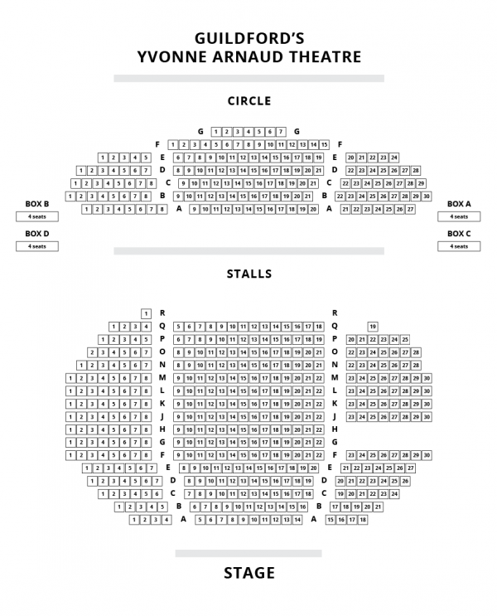

Appendix C – Hanging Plot
Please see hanging plot available on website.

